Utilitarianism and Capital Punishment
Name
Institution
Course
Professor
Date

Utilitarianism and Capital Punishment
For decades, the capital punishment has been a well-established, albeit divisive, practice in the United States. The practice extended to early English common law when nearly everyone convicted of a felony received capital punishment. However, it has always been far more popular in the United States. For most of the United States' history, capital punishment was expanded beyond murder to encompass, among other things, arson, aggravated burglary, assault, kidnapping, and the ownership of certain guns in connection with violent crimes. For some citizens, the consequences of "immoral" yet "acceptable" conduct pose an ethical dilemma.
The death sentence is undoubtedly the most contentious legal sanction enforced by the US criminal justice system. Due to its high brutality and severity, this sort of punishment stands out among the others. Due to the extreme perceived nature of the death sentence, there has been much debate over it, creating an ethical dilemma (Hickok and Williamson). Death penalty critics contend that it is barbaric and immoral and that the government should abolish it. On the other side, proponents believe that capital punishment is an essential type of retribution that should be applied to society's most heinous criminals (Hickok and Williamson). The question that emanates from this ethical dilemma is to what extent is the death penalty good or bad?
Since its inception, multiple opinion polls have demonstrated that most Americans have embraced the death sentence. On the other hand, recent polls have shown the lowest levels of support for the death sentence in decades, particularly now that people are increasingly motivated by human rights concerns and morals norms. Some several scenarios and reasons make some individuals accommodative of the death penalty. For instance, political leanings have also been linked to death penalty backing, with Republicans showing more support for the death sentence than Democrats or Independents (Sethuraju et al, 2016).
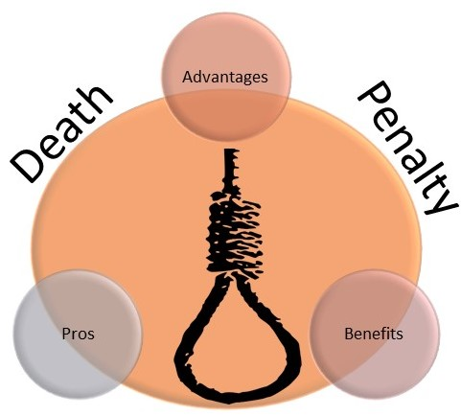
Figure 1 Death penalty, advantages and disadvantages

People favor the death sentence for a variety of reasons, the most prevalent of which being retribution. Retribution proportional to the crime committed and retribution as revenge are two separate notions of retribution related to advocating capital punishment. The equal notion implies that an offender's punishment should be proportional to the harm inflicted by their criminal activities (Sethuraju et al, 2016). Those who favor the death sentence under revenge typically assume that the execution will alleviate the suffering of those harmed by the crime of manslaughter should have their life cut short as a form of punishment. Another common justification for the death sentence is the belief that executing criminals deters others from committing similar criminal acts. Others who favor the death penalty do so because they consider it is essential to keep society's law and order (Sethuraju et al, 2016). This is linked to the notion of enforcing social control by state brutality and punishment. To some extent, these arguments demonstrate that a death sentence can be "somewhat beneficial."
Nevertheless, for opponents, the most common reason for their opposition to capital punishment is a moral concern (Sethuraju et al, 2016).These people believe that killing someone by the state is immoral or wrong. An additional reason is the prospect of an innocent person being murdered, especially in light of recent incidents of people on death row who were unfairly tried. For some religious groups, the idea of capital punishment is incompatible with their core beliefs of taking a life (Sethuraju et al, 2016).
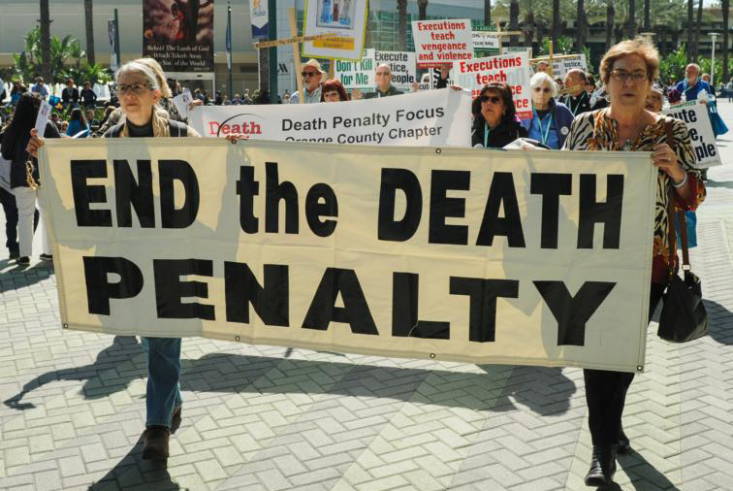
Figure 2 Citizens' demonstration against the death penalty

For decades, there has been a fiercely contentious debate about the death penalty. Ethical theories can be applied to provide a solution to this hotly debated problem. What is the proper course of conduct in a given scenario determined by ethics? Philosophers and intellectuals have proposed various solid ethical theories over the years, such as the Utilitarian theory. Since it advises us to consider the varying amounts of good and harm generated by our activity, utilitarianism is one of the most prevalent methods to making ethical decisions, especially decisions having implications that affect masses of people (Brown). John Stuart Mill first suggested utilitarianism, which is a famous and extensively used ethical philosophy.
The moral quality of action can be done by comparing its net utility, according to this theory. As per the utilitarian, ethical action is one that "optimizes the happiness of the greatest number of people." Actions are categorized as having either positive or negative outcomes (Brown). This corresponds to the belief that human actions will always cause some good and some evil and that the right decision will be the one that produces the best or the least destructive, or, to put it differently, the greatest balance of good over harm (Brown). The most ethical environmental activity, then, is the one that benefits the most people while causing the least harm to the environment. This includes government, business, the community, and the environment.
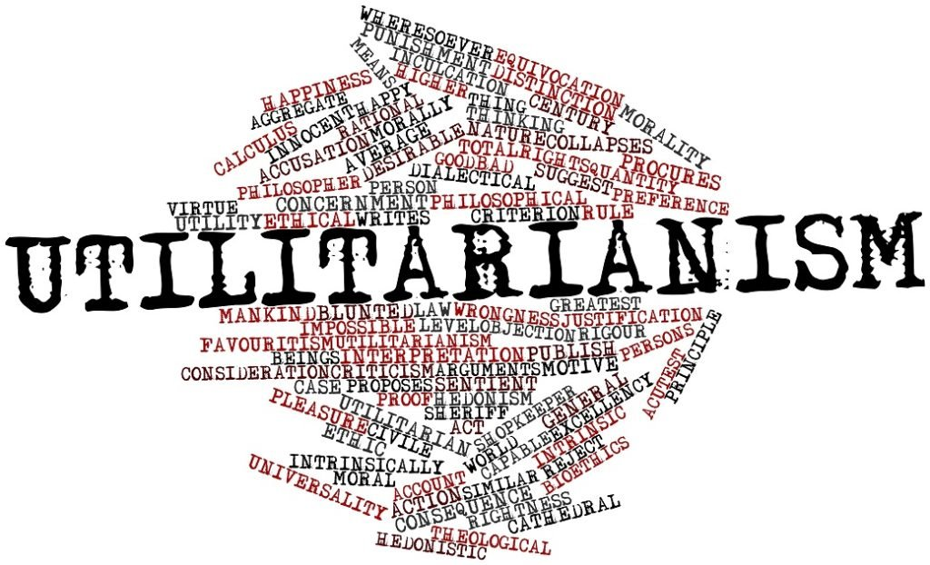
Figure 3 Utilitarianism theory

To use utilitarianism to establish the ethical quality of an activity, one must weigh the advantages against the consequences. Crime prevention, incapacitation, retribution, and the maintenance of law and order are all advantages of the death penalty in this case. On the other side, the costs are high, and there is a risk of innocent lives being lost (Hickok and Williamson). The advantages of carrying out the death sentence exceed the disadvantages. As a result, from a utilitarian standpoint, the death sentence is ethical since it has a net good effect, resulting in the maximizing of the happiness of the greatest number of individuals (Hickok and Williamson).
The Utilitarian theory approves of capital punishment as an ethical process and advocates for it, which, in my opinion, creates more dilemmas for those who do not support death penalties. The debate has shifted away from broad moral, intellectual, and theological arguments about the death sentence and more specific issues. The question of whether the death penalty system can make proper judgments, if the protocols are fair, and if it has a disproportionate effect on certain groups of people remains unanswered; hence the dilemma continues.

References
Brown University. (n.d.). A Framework for Making Ethical Decisions. A Framework for Making Ethical Decisions | Science and Technology Studies. https://www.brown.edu/academics/science-and-technology-studies/framework-making-ethical-decisions.
Hickok,, A. D., & Williamson,, J. J. (n.d.). An Inquiry into the Ethics of Capital Punishment. Syracuse Journal of Law Civic Engagement. https://slace.syr.edu/issue-2-on-life-and-death/inquiry-into-ethics-of-capital-punishment/
Sethuraju, R., Oliver, B. E., & Sole, J. (2016, January 5). Understanding death Penalty support and opposition Among criminal justice and law Enforcement students - Raj Sethuraju, JASON Sole, Brian E. oliver, 2016. SAGE Journals. https://journals.sagepub.com/doi/10.1177/2158244015624952#_i1.

